# UNITED STATES

The [OECD Regional Outlook](https://www.oecd-ilibrary.org/urban-rural-and-regional-development/oecd-regional-outlook_2dafc8cf-en) reviews recent trends, policy developments, and prospects across OECD regions, including the underlying causes driving regional inequalities in performance and well-being. The report offers evidence, guidance and policy recommendations on how to improve competitiveness and productivity, promote inclusive growth, accelerate the net-zero transition and raise well-being standards through effective regional development policy and multi-level governance.

## Territorial definitions

The data in this note reflect different sub-national geographic levels in OECD countries. In particular, **regions** are classified on two territorial levels reflecting the administrative organisation of countries: large regions (TL2) and small regions (TL3). In Canada, TL2 corresponds to the provinces and territories.

Small regions are classified according to their access to metropolitan areas (Fadic et al. 2019). The typology classifies small (TL3) regions into metropolitan and non-metropolitan regions according to the following criteria:

* **Metropolitan regions**, if more than half of the population live in a FUA. Metropolitan regions are further classified into **metropolitan large**, if more than half of the population live in a (large) FUA of at least 1.5 million inhabitants; and **metropolitan midsize**, if more than half of the population live in a (midsize) FUA of at 250 000 to 1.5 million inhabitants.
* **Non-metropolitan regions**, if less than half of the population live in a midsize/large FUA. These regions are further classified according to their level of access to FUAs of different sizes: **near a midsize/large FUA** if more than half of the population live within a 60-minute drive from a midsize/large FUA (of more than 250 000 inhabitants) or if the TL3 region contains more than 80% of the area of a midsize/large FUA; **near a small FUA** if the region does not have access to a midsize/large FUA and at least half of its population have access to a small FUA (i.e. between 50 000 and 250 000 inhabitants) within a 60-minute drive, or contains 80% of the area of a small FUA; and **remote**, otherwise.

Disclaimer: <https://oecdcode.org/disclaimers/territories.html>

Overview

|  |  |
| --- | --- |
| Population *(specify date)* and territory | 334,233,854 (as of Jan 1, 2023), 3,533,038.28 mi² |
| Administrative structure *(unitary/federal)* | Federal |
| Regional or state-level governments *(number)* | 50 states and 14 territories |
| Intermediate-level governments *(number)* | 3,031 (Census of Governments, 2017)  Note: The above data reflects County governments. Also note: The Census of Govt’s is conducted every 5 years. The 2022 census datasets have yet to be released. |
| Municipal-level governments *(number)* | 35,748 (Census of Governments, 2017)  Note: The above data reflects Subcounty Governments (Municipal and Townshhip Governments). Also note: The Census of Govt’s is conducted every 5 years. The 2022 census datasets have yet to be released. |
| Share of subnational government in total expenditure/revenues (2021) | 40.6% of total expenditure  57.8% of total revenues  [Source: [Subnational governments in OECD countries: key data, 2023 edition](https://stats.oecd.org/Index.aspx?DataSetCode=SNGF)] |
| Key regional development challenges | Inequity, broadband/digital infrastructure, access to capital, bridging the urban-rural divide |
| Objectives of regional policy | Achieve equitable economic development outcomes across the United States  Build the foundation for long-term, sustainable economic development. |
| Legal/institutional framework for regional policy | Federal economic development policies/programs across several federal agencies as well as state and local government policies/programs. |
| Budget allocated to regional development (i.e., amount) and fiscal equalisation mechanisms between jurisdictions (if any) | There are no set allocations, but most recently available data show the USG spent $27 billion on community and regional development in FY 2019. There are no fiscal equalisation mechanisms in the U.S. |
| National regional development policy framework | While there is no overarching national regional development policy framework per se, the US Economic Development Administration (EDA) leads the federal economic development agenda. |
| Urban policy framework | Led by U.S. Department of Housing and Urban Development (HUD) Office of Community Planning and Development. |
| Rural policy framework | Led by United States Department of Agriculture (USDA) - Rural Development. |
| Major regional policy tools (e.g., funds, plans, policy initiatives, institutional agreements, etc.) | EDA grants (capacity-building and infrastructure)  HUD Community Development Block Grant program (CDBG)  USDA Rural Development grant programs  White House Domestic Policy Council |
| Policy co-ordination tools at national level | White House Domestic Policy Council  EDA, serving as the lead of the federal economic development agenda, coordinates federal economic development policies and programs through its Economic Development Integration (EDI) initiative.  Rural Partners Network (rural.gov) |
| Multi-level governance mechanisms between national and subnational levels (e.g., institutional agreements, Committees, etc.) | Federal grants to subnational governments.  Regulatory framework as it applies to subnational governments |
| Policy co-ordination tools at regional level | State and Local government economic development departments/ offices  Regional Planning Organizations [e.g.: EDA funded Economic Development Districts (EDDs)] |
| Evaluation and monitoring tools | Federal agencies are required to evaluate and monitor impacts of programs through the Government Performance and Results Act (GPRA). |
| Future orientations of regional policy | Example: EDA’s grant making Investment Priorities:   1. **Equity:** Economic development planning or implementation projects that advance equity across America through investments that directly benefit 1) one or more traditionally underserved populations, including but not limited to women, Black, Latino, and Indigenous and Native American persons, Asian Americans, and Pacific Islanders or 2) underserved communities within geographies that have been systemically and/or systematically denied a full opportunity to participate in aspects of economic prosperity such as Tribal Lands, Persistent Poverty Counties, and rural areas with demonstrated, historical underservice. 2. **Recovery & Resilience:** Economic development planning or implementation projects that build economic resilience to and long-term recovery from economic shocks, like those experienced by coal and power plant communities, or other communities impacted by the decline of an important industry or a natural disaster, that may benefit from economic diversification-focused resilience. 3. **Workforce Development:** Economic development planning or implementation projects that support workforce education and skills training activities directly connected to the hiring and skills needs of the business community and that result in well-paying, quality jobs (PDF). 4. **Manufacturing:** Economic development planning or implementation projects that encourage job creation, business expansion, technology and capital upgrades, and productivity growth in manufacturing, including efforts that contribute to the competitiveness and growth of domestic suppliers or to the domestic production of innovative, high-value products and production technologies. 5. **Technology-Based Economic Development:**   Economic development planning or implementation  projects that foster regional knowledge ecosystems that support entrepreneurs and start-ups, including the commercialization of new technologies, that are creating technology-driven businesses and high-skilled, well-paying jobs of the future.   1. **Environmentally-Sustainable Development:**   Economic development planning or implementation projects that help address the climate crisis including through the development and implementation of green products, green processes (including green infrastructure), green places, and green buildings.   1. **Exports & FDI:** Economic development planning or implementation projects that enhance or build community assets to support growth in US exports or increased foreign direct investment. |
|  |  |

## Regional Inequality Trends

The United States experienced an increase in the Theil index of GDP per capita over 2000-2020. Inequality reached its maximum in 2010. The figures were normalized, with the values in the year 2000 set to 1.

Polarisation, as measured by the Top 20%/Mean ratio was 0.063 higher in 2000 compared to 2020. Bottom divergence, as measured by the Bottom 20%/Mean ratio was 0.026 lower in the same period.

**Figure 1. Trends in GDP per capita inequality indicators, TL2 OECD regions**

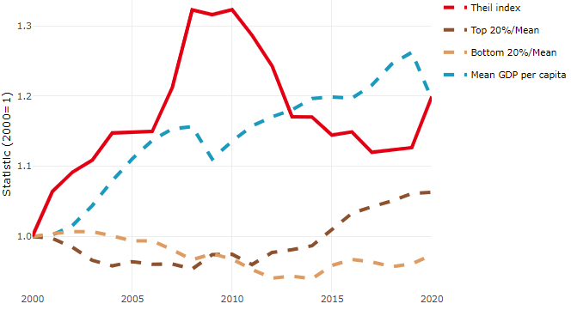

**Note**: Top/bottom calculated as population equivalent (top/bottom regions with at least 20% of the population). The interpretation of top/bottom 20% GDP per capita is that 20% of the population in the country holds 20% of the value. Top 20%/Mean calculated as mean GDP per capita in top 20% regions over mean TL3 GDP per capita in a given year. Bottom 20%/Mean calculated as mean TL3 GDP per capita in bottom 20% regions over mean TL3 GDP per capita in a given year. To improve data consistency, input series are aggregated when TL3 regions are part of the same FUA. To improve time series, TL3 missing values have been estimated based on the evolution at higher geographic level.

**Source**: OECD Regional Database (2022).

In 2020, the gap in GDP per capita between large metropolitan and non-large metropolitan regions was 1.307. For reference, the same value for OECD was 1.475. This gap decreased by 0.028 percentage points between 2000 and 2020.

Meanwhile, in 2020, the gap in GDP per capita between metropolitan and non-metropolitan regions was 1.126. For reference, the same value for OECD was 1.325. This gap decreased by 0.051 percentage points since 2000.

In turn, the gap in GDP per capita between regions near and far a Functional Urban Area (FUA) of more than 250 thousand inhabitants was 1.115 in 2020 and decrease by 0.06 percentage points since 2000.

**Figure 2. GDP per capita gap by type of region compared to the OECD average**

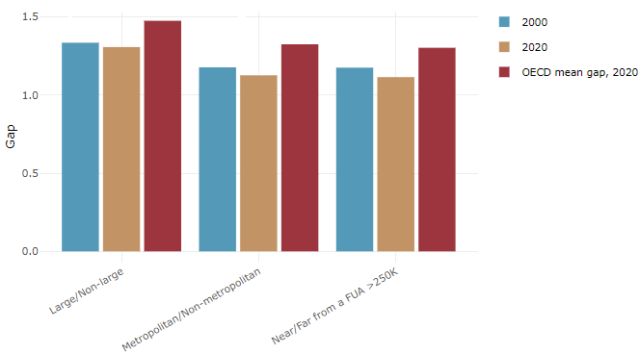

**Note**: Far from a FUA>250K includes regions near/with a small FUA and remote regions. OECD mean gap based on 1 586 TL3 regions in 27 countries with available data (no TL3 data for Australia, Canada, Chile, Colombia, Costa Rica, Iceland, Ireland, Israel, Mexico, Luxembourg and Switzerland).

**Source**: OECD Regional Database (2022).

In the United States, the gap between the upper and the lower half of regions in terms of labour productivity increased between 2001 and 2019. Over this period labour productivity in the upper half of regions grew roughly by 24%, 1 percentage points more than in the lower half of regions. During 2020, the gap continued to widen. Nevertheless, more years of data are necessary to determine the long-term impact of the COVID-19 pandemic on labour productivity gaps in regions.

**Figure 3. Evolution of labour productivity, TL2 OECD regions**

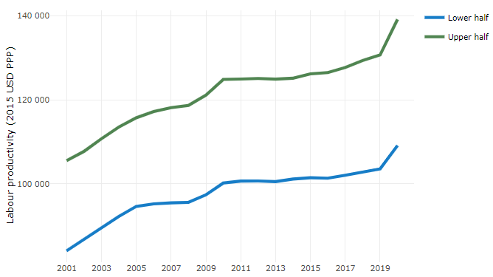

**Note**: A region is in the “upper half” if labour productivity was above the country median in the first year with available data and “lower half” if productivity was below the country median. Labour productivity in each group is equal to the sum of Gross Value Added, expressed in USD at constant prices and PPP (base year 2015) within the group, divided by the sum of total employment in regions within the group. Regions are small (TL3) regions, except for Australia, Canada, Chile, Colombia, Ireland, Mexico, Norway, Switzerland, Türkiye and the United States where they are large (TL2) regions due to data availability.

**Source**: OECD Regional Database (2022).

Regions where the economic activity shifts towards tradable activities, such as industry and tradable services, tend to grow faster in terms of labour productivity. In the United States, between 2001 and 2020, the share of workers in the industrial sector remained approximately stable across all regions. At the same time, the share of workers in the tradable services sector went up in all regions, approximately by the same amount.

**Figure 4. Share of workers in most productive (tradable) sectors, TL3 OECD regions**

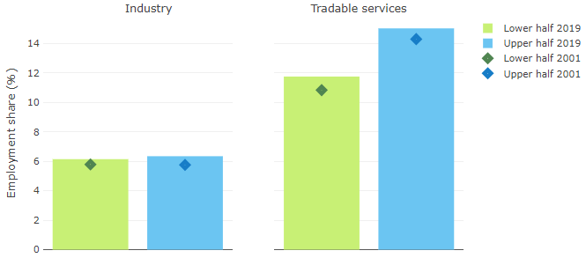

**Note**: A region is in the “upper half” if labour productivity was above the country median in the first year with available data and “lower half” if productivity was below the country median. The share of workers in a given sector for a group of regions is defined as the sum of employment in that sector within the group divided by the sum of total employment within the group. Regions are small (TL3) regions, except for Australia, Canada, Chile, Ireland, Mexico, Norway, Switzerland, Türkiye and the United States where they are large (TL2) regions due to data availability. Industry includes the following tradable goods sectors: Mining and quarrying (B), Manufacturing (C), Electricity, gas, steam and air conditioning supply (D) and Water supply; sewerage; waste management and remediation activities (E) NACE macro sectors. Tradable services include Information and communication (J), Financial and insurance activities (K), Real estate activities (L), Professional, scientific and technical activities (M), Administrative and support service activities (N).

**Source**: OECD Regional Database (2022).

## Recent policy developments

The United States has always had a focus on policies that address place-based needs. Most recently, there has been a greater emphasis on equity, especially for historically underserved geographies and populations. This includes rural areas, tribal lands, and minorities such as Black, Latino, and American Indian populations. The U.S. is taking a whole of government approach to address regional inequalities. In terms of new initiatives, a key example is EDA’s recent $3 billion American Rescue Plan program to meet the urgent needs of American communities for economic recovery and resiliency in face of the pandemic. In 2022, EDA made 780 grants awarded through six innovative programs to support transformational American Rescue Plan projects.

EDA’s American Rescue Plan grant programs include:

1. [Build Back Better Regional Challenge](https://www.eda.gov/arpa/build-back-better): $1 billion awarded to 21 regional coalitions (5-8 component awards per coalition), each of which received between $25 million and $65 million to transform their regional economy by growing an industry sector. EDA also gave awards to 60 phase 1 finalists to support the development of their ambitious projects.
2. [Good Jobs Challenge](https://www.eda.gov/arpa/good-job-challenge): $500 million awarded to 32 industry-led workforce training partnerships to invest in innovative approaches to workforce development that will secure job opportunities for more than 50,000 Americans.
3. [Economic Adjustment Assistance program](https://www.eda.gov/arpa/economic-adjustment-assistance): $500 million awarded to 256 diverse projects —including but not limited to enabling infrastructure, workforce development, business facilities and planning grants — to address the economic development needs of communities today while preparing them for the future by in investing in enabling infrastructure, workforce development, business facilities, and planning grants.
4. [Indigenous Communities program](https://www.eda.gov/arpa/indigenous): $100 million awarded to 51 grantees to support economic development projects in Indigenous communities for similar types of projects as described under Economic Adjustment Assistance. Across all six American Rescue Plan programs, inclusive of the Indigenous Communities program, EDA awarded a total of 127 grants totalling $448 million.
5. [Travel, Tourism & Outdoor Recreation program](https://www.eda.gov/funding/programs/american-rescue-plan/travel-tourism): $750 million awarded to 185 grantees to help support regions hard hit by declines to these industries through projects to build new tourist attractions (museums, event venues, hiking trails, campgrounds, etc.), develop tourism-related economic plans, and support workforce training in the tourism sector.
6. [Statewide Planning, Research & Networks](https://www.eda.gov/arpa/research): $1 million planning grants to each of the 59 U.S. states and territories and $31 million to 14 research and networks (also known as Communities of Practice) grantees.